|  |
| --- |
| **Weather Forecasting** |
| |  | | --- | |  | | ***A report submitted in partial fulfilment of the***  ***requirement for the award of certification of***  ***IN-HOUSE SUMMER TRAINING***  ***in***  ***Machine Learning and Deep Learning*** | |  | | ***By*** | | **Jitender Pratap Singh(IT2) – 00651207719**  **Komal Kumar(IT2) – 00351207719** | |  | | ***under the guidance of*** | |  | | **Dr. Rachna Jain, Dr. Preeti Nagrath, Dr. Ashish gupta, Dr. Nikita Sharma**  ***Assistant Professors***  ***Computer Science and Engineering*** | | **Computer Science and Engineering**  **Bharati Vidyapeeth’s College of Engineering,**  **New Delhi – 110063, INDIA**  **June 2020** | |
|  |

**Table of Contents**

**List of Figures 1**

**List of Tables** **2**

**Certificate** **3**

**Acknowledgements** **4**

**Abstract** **5**

**Chapter** **1.** **Introduction 6**

**Chapter 2****. REVIEW OF LITERATURE** **8**

**2.1 HISTORICAL BACKGROUND OF WEATHER FORECASTING………….8**

**2.2 APPROACHES FOR WEATHER FORECASTING…………………………...8**

**2.3 GAPS IN EXISTING RESEARCH………………………………………………10**

**2.4 CONCLUSION OF LITERATURE REVIEW………………………………….10**

**2.5 OBJECTIVES OF PROPOSED RESEARCH WORK………………………….11**

**2.6 PROPOSED APPROACH………………………………………………………...11**

**Chapter** **3. Different Approaches****12**

**Chapter** **4.**  **First Approach - Using Machine Learning** **13**

**4.1 Linear Regression……………...…………………………………..13**

**4.2 Linear Regression Learning the Model…………………..………13**

**4.3Temperature Prediction…………………………...………………14**

**4.4Rainfall Prediction…………………………………………………15**

**Chapter 5:Second Approach- Using Deep Learning** **17**

**5.1 Wind Prediction................................................................................17**

**5.2 LSTM………………………………………………………………17**

**5.3 Result using LSTM..........................................................................18**

**Chapter** **6.** **Conclusion** **20**

**References** **21**

**Certificate**

I hereby certify that the work which is being submitted in this report titled **“Weather Forecasting”**, in partial fulfilment of the requirement for the award of certification of “In-House Summer Training in Machine Learning and Deep Learning” submitted in Bharati Vidyapeeth’s College of Engineering, New Delhi, is an authentic record of my own work carried out under the supervision of Dr. Rachna jain and refers to other researchers work which are duly listed in the reference section.

The matter presented in this report has not been submitted for the award of any other certificate of this or any other institution.

**(Jitender Pratap Singh(IT2)) (Komal Kumar(IT2))**

Roll No. **00651207719** Roll No. **00351207719**

This is to certify that the statements made above by the candidate are correct and true to the best of our knowledge.

|  |  |
| --- | --- |
| **(Dr. Rachna Jain)**  **Assistant Professor**  Computer Science & Engineering  BVCOE  New Delhi – 110063 | **(Dr. Preeti Nagrath)**  **Assistant Professor**  Computer Science & Engineering  BVCOE  New Delhi – 110063 |

The Viva-Voce Examination of ___________________________ has been held on _____________________________.

Internal Examiner External Examiner

**Acknowledgements**

We would like to express my special thanks of gratitude to my teacher ***Dr. Rachna Jain, Dr. Preeti Nagrath, Dr. Ashish gupta, Dr. Nikita Sharma*** who gave us the golden opportunity to do this wonderful project on the topic Weather Forecasting, which also helped us in doing a lot of Research and we came to know about so many new things we are really thankful to them. Secondly we would also like to thank our friends who helped us a lot in finalizing this project within the limited time frame.

**(Jitender Pratap Singh(IT2)) (Komal Kumar(IT2))**

**00651207719 00351207719**

**Bharati Vidyapeeth's College of Engineering, New Delhi.**

**Abstract**

Weather forecasting has been playing an important factor due to it’s applications in the various sectors such as in agriculture, utility company and in day to day life. Weather prediction is a real-time challenging issue witnessed by the world in the last decade. The prediction is becoming more complex due to the ever-changing weather conditions. Weather forecasting dntails predicting how the present state of the atmosphere will change. For effective analysis of the weather, it is necessary to understand various influencing factors that cause the weather changes. Weather forecasting is the process of recording the parameters of weather like wind direction, wind speed, humidity, rainfall, temperature etc. Since machine learning techniques are more robust to perturbations, in this project we applied linear regression to predict the weather such as temperature, rainfall etc. and compare both approaches and analyzed it. We used two different datasets for the same. Coming to result that we got from each approaches was quite amazing. In the linear regression approach, we got mean absolute error about 96.32 mm and 2.69 celsius when performing rainfall and temperature prediction respectively whereas in the deep learning approach.

**Chapter 1: Introduction**

Weather conditions changes rapidly, weather forecast is a vital process, weather forecasting is a process of collecting data on atmospheric conditions, which records the temperature, humidity, rainfall, wind speed and its direction etc. high-speed computers, wired and wireless sensors, meteorological satellites and weather radars are the tools used to collect the weather data for weather forecasting. Weather is so popular that there is now a television channel completely devoted to weather issues.

Weather can have a substantial impact on the economy, especially agriculture but other areas as well. The 2005 hurricanes Katrina and Rita caused an extensive shutdown of oil and gas rigs in the Gulf of Mexico resulting in a significant spike in energy prices while the 2006 freeze in California caused hundreds of millions of dollars in losses to citrus growers and widespread unemployment.

There are many applications that this system is used such as Air Traffic, Agriculture, Marine, Forestry, Navy, and Military etc.  The weather forecasting methods used in the ancient time usually implied pattern recognition i.e., they usually rely on observing patterns of events. For example, it is found that the following day has brought fair weather; if the preceding day sunset is particularly red. However, all of the predictions prove not to be reliable. Here in this system, we used parameters like average temperature, cloud cover to predict the rainfall. Two machine and deep learning algorithms were implemented: linear regression and artificial neural networks. A corpus of historical weather data for Denmark and India was obtained and used to train these algorithms.

The Linear Regression method is modified in order to obtain the most optimum error percentage by iterating and adding some percentage of the error to the input values. This method provides an estimate of rainfall using different atmospheric parameters like average temperature and cloud cover to predict the rainfall. The linear regression is applied to the set of data and the coefficients are used to predict the rainfall based on the corresponding values of the parameters. The main advantage of this model is that this model estimates the rainfall based on the previous correlation between the different atmospheric parameters.

Thus, an estimated value of what the rainfall could be at a given time period and place can be found easily.

There are four types of forecasting-

1. Climatology method - The climatology method offers a simple technique for generating a weather forecast. They predict the weather for a specific day and location based on the weather conditions for that same day for several years in the past.
2. Analog method - The analog method is a difficult method to use when predicting the weather because it requires finding a day in the past with weather similar to the current forecast, which is difficult to do. For example, suppose the current forecast indicates a warm day with a cold front imminent in the region of the forecast.
3. Persistence and trends method- The persistence and trends method requires little to no skill to predict the weather because it relies on past trends. In an ideal world, the atmosphere changes slowly, which equates to a forecast tomorrow that stays the same as today, with a hat tip to the climate's norm for the specific time of year.
4. Numerical weather prediction- Numerical weather prediction relies on computers to predict the weather. Massive supercomputers, complete with software forecasting models, help meteorologists make weather predictions based on multiple conditions in the atmosphere such as temperatures, wind speed, high- and low-pressure, rainfall and other conditions.

CHAPTER 2 REVIEW OF LITERATURE

2.1 HISTORICAL BACKGROUND OF WEATHER FORECASTING

The livelihood of over 60 per cent of the world's population depends upon the monsoons, of which the Asian summer monsoon is the largest. Accurate predictions of the monsoons, at least a season in advance, are therefore crucial for the monsoon regions. Furthermore, the Asian summer monsoon is a key component of the earth's climate system, having important tele-connections with global weather and climate (Walter Maner, 1997).

Following the Great Indian Drought of 1877, H.F. Blanford, who had established the India Meteorological Department in 1875, issued the first seasonal forecast of Indian monsoon rainfall in 1884. Later, in the early part of the 20th century, Sir Gilbert Walker initiated extensive studies of global teleconnections which led him to the discovery of Southern Oscillation. Walker introduced, for the first time, the concept of correlation for long-range forecasting of the Asian summer monsoon and his findings are relevant even today.

More than 100 years later, forecasts of the Asian summer monsoon is still being made using statistical regression, often with remarkable success. General circulation models are also capable of capturing some of the features of the Asian summer monsoon and may be able to give improved short-term forecasts.

Generally, there are two methods that are used in weather forecasting one is empirical approach and other is dynamical approach (Lorenz, 1969). The empirical approach is based upon the occurrence of analogues and is often referred to by meteorologists as analogue such as changes in barometric pressure, current weather conditions, sky condition to determine the future conditions (Ozelkan, 1996). This approach normally is useful for predicting local-scale weather if recorded case are very large in number.

**2.2 APPROACHES FOR WEATHER FORECASTING**

Numerical weather prediction is the prediction of weather phenomena by the numerical solution of the equations governing the motion and changes of condition of the atmosphere. Numerical weather prediction techniques, in addition to being applied to short-range weather prediction, are used in such research studies as air-pollutant transport and the effects of greenhouse gases on global climate change.

The first operational numerical weather prediction model consisted of only one layer and therefore it could model only the temporal variation of the mean vertical structure of the atmosphere. Computers now permit the development of multilevel (usually about 10–20) models that could resolve the vertical variation of the wind, temperature and moisture. These multilevel models predict the fundamental meteorological variables for large scales of motion

The complexities in the relationship between rainfall and sea surface temperature (SST) during the winter monsoon (November-January) has been observed by Goutami Chattopadhyay *et al.* (2008). Evaluation is done statistically using scatter plot matrices and autocorrelation functions. Linear as well as polynomial trend equations were obtained and it was observed that the coefficient of determination for the linear trend was very low and it remained low even when polynomial trend of degree six was used. An exponential regression equation and an artificial neural network with extensive variable selection were generated to forecast the average winter monsoon rainfall of a given year using the rainfall amounts and the sea surface temperature anomalies in the winter monsoon months of the previous year as predictors. The artificial neural network was generated in the form of a multi-layer perceptron with sigmoid non-linearity and genetic- algorithm based variable selection. Both of the predictive models were judged statistically using the Wilmot’s index, percentage error of prediction and prediction yields. The statistical assessment revealed the potential of artificial neural network over exponential regression.

Neural Networks are good at recognizing patterns; they are not good at explaining how they reach their decisions. Neural Networks can only come into play if the problem is expressed by a sufficient amount of observed examples. These observations are used to train the black box. On the one hand no prior knowledge about the problem needs to be given and it is not straight forward to extract comprehensible rules from the neural network's structure (Fuller, 1995).

Fuzzy logic systems, which can work with imprecise information, are good at explaining their decisions but they cannot automatically acquire the rules they use to make those decisions. A fuzzy system demands linguistic rules instead of learning examples as prior knowledge. Furthermore the input and output variables have to be described linguistically. If the knowledge is incomplete, wrong or contradictory, then the fuzzy system must be tuned (Fuller, 1995).

Since there is not any formal approach for rule construction, the tuning of membership function is performed in a heuristic way. This is very time consuming and error-prone.

Hybridization of systems combining Fuzzy logic, Neural Networks are proving their effectiveness in a wide area of real world problems. Every intelligent system has particular ability to learn that make them suited for particular problems and not for others (Fuller, 1995).Moreover, it is clear that the performance of ANFIS can predict weather condition accurately.

**2.3 GAPS IN EXISTING RESEARCH**

After a comprehensive study made on the existing literature, a lot of limitations/gaps have been found in the area of weather forecasting:

* + - Majority of work reported for weather forecasting problems has been done using various statistical methods like Curve Fitting, Regression Analysis, ARIMA model etc. which have their own limitations. Hence a more attention is required towards a new approach for weather forecasting.
    - It may conclude from the literature survey that a lit bit attention has been paid in South Western monsoonal seasonal precipitation prediction. Hence a more research is required towards this.
    - Most of the works reported on weather forecast has paid focus on objective weather forecasting system, not so much attention has been given for the subjective weather forecasting which produces more accurate results.
    - Most of work with the weather forecasting using soft computing is done. There is limited work towards hybridization of Neural Network and Fuzzy System in weather forecasting. Hence more emphasis is required towards it.

# CONCLUSION OF LITERATURE REVIEW

From the survey of literature, it is concluded that soft computing techniques especially Neural Network and Fuzzy System has become interesting preference for researchers to solve weather forecasting problems. Development of hybridization of Neural Network and Fuzzy System are still the major issues related to weather forecasting which include forecasting of Local Monsoonal Precipitation (LMP). Therefore, in the present work, weather forecasting system for LMP problem with very good performance measures including very less Root Mean Square Error (RMSE) have been considered. An attempt has been made to develop hybrid algorithm that is based on combination of powers of two algorithms Neural Network and Fuzzy System for weather forecasting of Local Monsoonal Precipitation has been done.

# 2.5 OBJECTIVES OF PROPOSED RESEARCH WORK

* To Identify and characterize different Agrometeorological parameters that can be used as input variable for Neuro Fuzzy Technique using SPSS.
* To propose a new approach using hybridization of Fuzzy Inference System and Neural Networks on weather data for Agrometeorological weather forecasting process, optimizing agricultural production using ANFIS editor in MatLab.
* Assessment of the feasibility of proposed Soft Computing approach for Agrometeorological weather forecast and compare its performance analysis on the basis of Mean Squared Error (MSE) and Root Mean Squared Error (RMSE) with existing Best Statistical Model using various statistical tools in MatLab.

# 2.6 PROPOSED APPROACH

In the proposed research soft computing approach is applied to monsoonal weather analysis in Hisar, Haryana, India. A new approach is proposed that use concept of fuzzy logic in meteorology system. One method to understand such type of inconsistent problem is by using a technique that learns the pattern using the previous data like an adaptive neural network system until it reaches the required level of training error. Such technique is possible by using a hybridization of a neural network and Fuzzy Inference System. This is Adaptive Neuro Fuzzy Inference System called ANFIS.

ANFIS is integration of Artificial Neural Networks and fuzzy logic methods. It has the inherent quality to capture the benefits of both these methods in a single framework. ANFIS eliminates the basic problem in fuzzy system design (defining the membership function parameters and design of fuzzy if–then rules) by effectively using the learning capability of ANN for automatic fuzzy rule generation and parameter optimization. (Bacanli *et al*., 2009).

These limitations have been a big reason behind the formulation of an intelligent hybrid systems that overcomes the limitations of neural networks and fuzzy systems. Fuzzy systems required to have an automatic adaption procedure which is comparable to neural networks. Hybridizing both approaches should include advantages and exclude disadvantages of both the techniques.

**Chapter 3: Different Approaches**

For the weather forecasting, we try to solve the problem using two methods and those were-

* Machine Learning
* Deep Learning

We divide the problem using two methods and we have done so because of the following reasons-

* Tackle the problem with different approaches
* Will know what are the strengths and weaknesses of each method.
* Will know what are the difficulties one could face while approaching the problem with these two methods.
* Will know what is the efficiency of each process.

Coming to the first approach that is Machine Learning, here we have solved the problem of weather forecasting with linear regression. In this approach, weather forecasting like rainfall prediction and temperature prediction is done separately. Also, the linear model which was trained for temperature predictions and rainfall predictions were trained using ordinary least square and regularization respectively.

Now coming to the second approach that is Deep learning, here we have solved the problem of weather forecasting in a single stroke. Mean, only in one solution, we have done the forecasting of the temperature, wind speed, and pressure. We have trained our model on LSTM (advanced version of the RNN).

**Chapter 4:First Approach - Using Machine Learning**

The first algorithm that we used was linear regression, which seeks to predict the high and low temperatures as a linear combination of the features. Since linear regression cannot be used with classification data, this algorithm did not use the weather classification of each day.

## **4.1 Linear Regression**

Linear regression models are used to show or predict the relationship between two variables. The factor that is being predicted is called thedependent variable. The factors that are used to predict the value of the dependent variable are called the independent variables.

Single Variable Linear Regression is a technique used to model the relationship between a single input independent variable and an output dependent variable using a linear model. In Multi-Variable Linear Regression where a model is created for the relationship between multiple independent input variables and an output dependent variable. Linear regression is fast and easy to model and is particularly useful when the relationship to be modelled is not extremely complex and if you don’t have a lot of data.

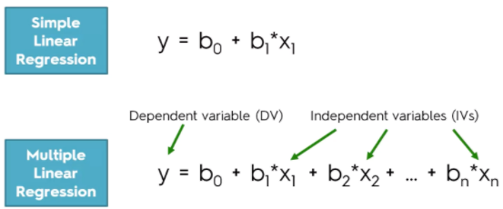

## **4.2 Linear Regression Learning the Model**

Learning a linear regression model means estimating the values of the coefficients used in the representation with the data that we have available.

Following are the four techniques to prepare a linear regression model-

1. Simple Linear Regression

2. Ordinary Least Squares

3. Gradient Descent

4. Regularization

## **4.3 Temperature Prediction**

**1- Collecting Data Set, and Filter process**

We started to collect out the dataset and we look out to various websites and found a dataset on Open Government Data ([data.gov.in/](https://data.gov.in/)) which consist of various attributes.

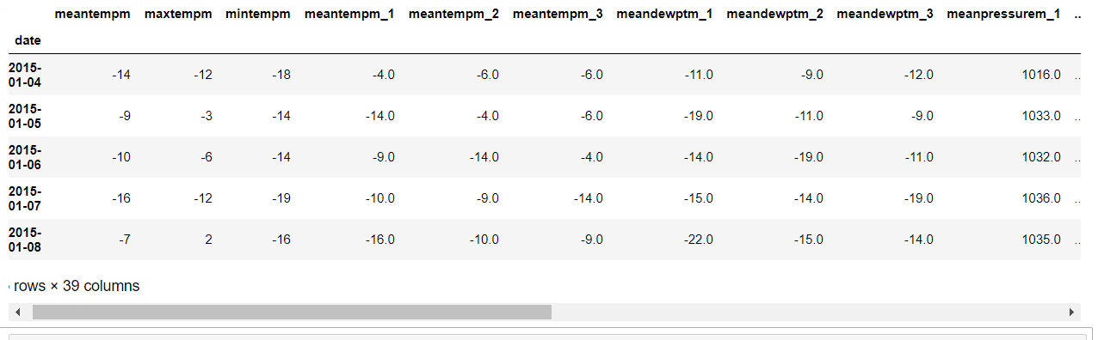

**2 -Training an LR model**

We need to perform temperature prediction, we went with linear regression. The Linear regression model used here was trained on Ordinary Least Squares technique, that is one of the above-mentioned technique. The model trained with OLS also known as Ordinary Least Squares Linear Regression. Following is the OLS Equation-

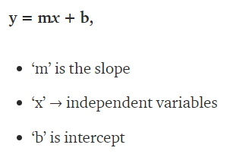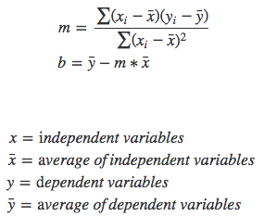

**3, Result**

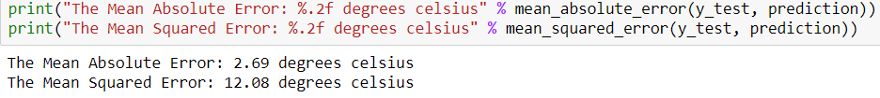

## **4.4 Rainfall Prediction**

**3.3.1- Collecting Data Set, and Filter process**

We started to collect out the dataset and we look out to various websites and found a dataset on Open Government Data ([data.gov.in/](https://data.gov.in/)) which consist of various attributes. Dataset used in the project is month and year-wise.

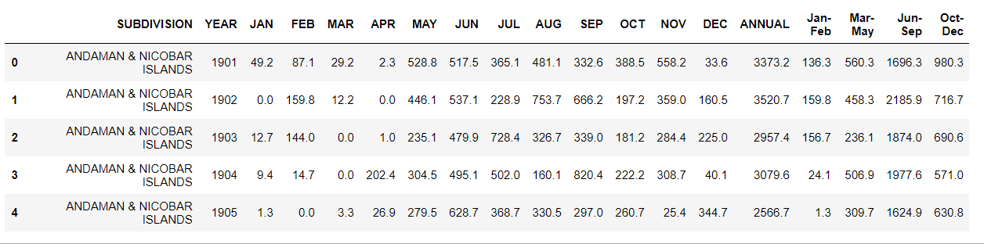

**4.3.2- Train an LR model**

We need to perform rainfall prediction, we went with the linear regression model using the regularization method. There are three types of the regularization method and those are Ridge, Lasso and Elastic Net.

Here we have used the Regularization of the Elastic Net version. Following is the Regularization of the Elastic Net version Equation-

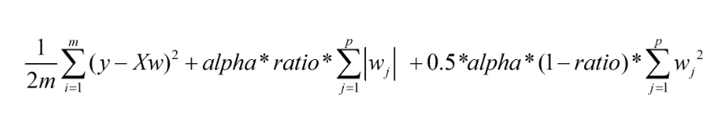

**4.3.3, Result**

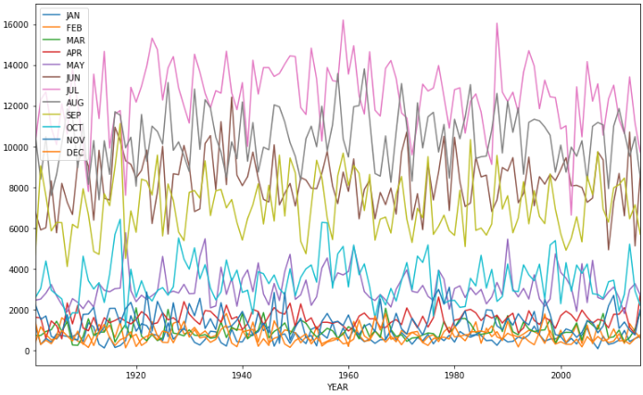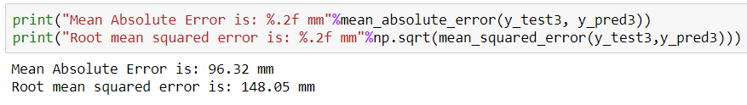

## **Chapter 5:Second Approach- Using Deep Learning**

## **5.1 Wind Prediction**

**5.1.1 Collecting Data Set, and Filter process**

We started to collect out the dataset and we look out to various websites and found a dataset on Open Government Data ([data.gov.in/](https://data.gov.in/)) which consist of various attributes. Dataset used in the project is month and year-wise.

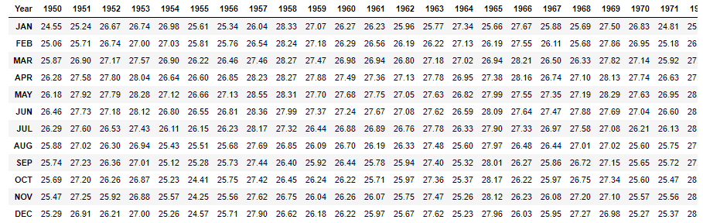

**5.2 LSTM**

Long Short-Term Memory (LSTM) is a specific recurrent neural network (RNN) architecture that was designed to model temporal sequences and their long-range dependencies more accurately than conventional RNNs. It processes data passing on information as it propagates forward. The differences are the operations within the LSTM’s cells. The core concept of LSTM’s are the cell state, and it’s various gates. LSTM introduces long-term memory into recurrent neural networks. It mitigates the vanishing gradient problem, which is where the neural network stops learning because the updates to the various weights within a given neural network become smaller and smaller. It does this by using a series of ‘gates’.

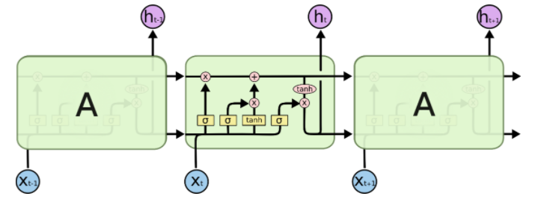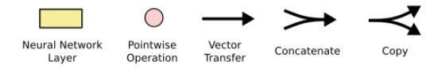

We have three different gates that regulate information flow in an LSTM cell. A forget gate, input gate, and output gate.

**Forget gate**

First, we have the forget gate. This gate decides what information should be thrown away or kept. Information from the previous hidden state and information from the current input is passed through the sigmoid function. Values come out between 0 and 1. The closer to 0 means to forget, and the closer to 1 means to keep.

**Input Gate**

To update the cell state, we have the input gate. First, we pass the previous hidden state and current input into a sigmoid function. That decides which values will be updated by transforming the values to be between 0 and 1 where 0 means not important, and 1 means important. You also pass the hidden state and current input into the tanh function to squish values between -1 and 1 to help regulate the network. Then you multiply the tanh output with the sigmoid output. The sigmoid output will decide which information is important to keep from the tanh output.

**Output Gate**

Last we have the output gate. The output gate decides what the next hidden state should be. Remember that the hidden state contains information on previous inputs. The hidden state is also used for predictions. First, we pass the previous hidden state and the current input into a sigmoid function. Then we pass the newly modified cell state to the tanh function. We multiply the tanh output with the sigmoid output to decide what information the hidden state should carry. The output is the hidden state. The new cell state and the new hidden is then carried over to the next time step.

**Cell State**

Now we should have enough information to calculate the cell state. First, the cell state gets pointwise multiplied by the forget vector. This has the possibility of dropping values in the cell state if it gets multiplied by values near 0. Then we take the output from the input gate and do a pointwise addition which updates the cell state to new values that the neural network finds relevant. That gives us our new cell state.

**5.3 Result using LSTM**

Here is the wind speed prediction, with wind speed (km/hr)

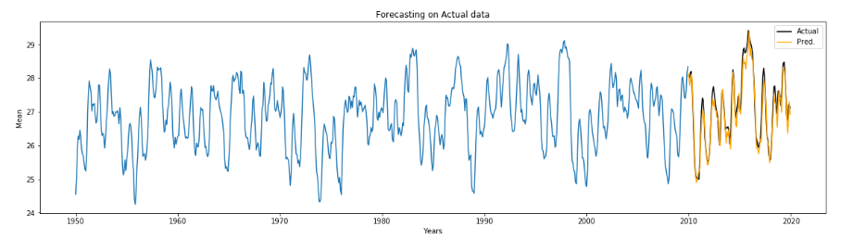

In the above graph, we could observe that there are is not much variance in the predicted result and observed the result except for some points.

**Chapter 6: Conclusion**

In this project, linear regression and deep learning are used to predict the weather forecasting. We divided the whole weather forecasting project into two parts. Compared to the machine learning approach, deep learning approach which was the deep learning approach gives the better result.

Weather forecasts are increasingly accurate and useful, and their benefits extend widely across the economy. While much has been accomplished in improving weather forecasts, there remains much room for improvement.

For future improvements, following step we thought to took-

* Replacing model with a latest/different model
* Using other robust datasets
* Predicting result on more attributes
* Training model on higher-end GPU

Also, while performing weather forecasting, there was a lot of complexities involved. There are a lot of variables/attributes to consider for forecasting weather and if all or most of them are used, then we need a lot of computation power to get weather information. And, Real time weather forecasting is very difficult to forecast correctly.

**References**

1. Parmar, Aakash&Mistree, Kinjal&Sompura, Mithila. (2017). Machine Learning Techniques for Rainfall Prediction: A Review.
2. Mateo, Fernando & Carrasco, Juan José &Sellami, Abderrahim&Millán-Giraldo, Mónica&Domínguez, Manuel & Olivas, Emilio. (2013). Machine learning methods to forecast temperature in buildings. Expert Systems with Applications. 40. 1061–1068. 10.1016/j.eswa.2012.08.030.
3. Pooja Malik, Prof. Saranjeet Singh, Binni Arora. An Effective Weather Forecasting Using Neural Network
4. Abhishek, Kumar & Singh, M. & Ghosh, Saswata&Anand, Abhishek. (2012). Weather Forecasting Model using Artificial Neural Network. Procedia Technology. 4. 311–318. 10.1016/j.protcy.2012.05.047.
5. Long Short-Term Memory Recurrent Neural Network Architectures for Large Scale Acoustic Modeling. Has¸im Sak, Andrew Senior, Franc¸oise Beaufays
6. Chatfield, C. (1994): The Analysis of Time Series-An Introduction. Chapman and Hall.
7. Sivakumar, B. (2001): Rainfall dynamics in different temporal scale: A Chaotic percepective. Hydrology and Earth System Science, Vol.5, pp. 645-651.
8. Guhathakurta, P. (2006). Long range of monsoon rainfall prediction of 2005 for the districts and sub-division in kerala with artificial neural network. Current science, Vol. 90, pp. 773-779.
9. Saima, H., Jaafar, J., Belhaouari, S. and Jillani, T.A. (2011): ARIMA based Interval Type-2 Fuzzy Model for Forecasting. International Journal of Computer Applications, Vol. 28, No. 3, pp. 17-21.
10. M.Tektas, “Weather Forecasting Using ANFIS and ARIMA (2010): A Case study of Istanbul,” Enviornment Research , Engineering and Management , vol. 1(51), pp.5-10.
11. Mahmudur Rahman, A.H.M. Saiful Islam , Sahah Yaser Maqnoon Nadvi , Rashedur M Rahman (2013) : Comparative Study of ANFIS and ARIMA Model for weather forecasting in Dhaka” IEEE.
12. Sarah N. kohail, Alaa M. EI-Halees(2011): “Implementation of Data Minning Technique for Metrological Data Analysis”,IJICT Journal Volume 1 No.3, july
13. S.A. Shamsnia, N. Shahidi, A. Liaghat, A.Sarraf and S.F. Vahdat. 2011. Modeling Of Weather Parameters Using Stochastic Methods. Internat. Conference on Environment and Industrial Innovation, IPCBEE, Singapore, 282-285.
14. R Development Core Team (2008). R: A language and environment for analytic computing. R Foundation for Statistical Computing, Vienna, Austria. ISBN 3-900051-07-0, URL http://www.Rproject. org.
15. Montgomery, D.C., and Lynwood A.J. (1996): Forecasting and Time Series Analysis, Mc. Graw-Hill.
16. Abramson, Bruce, et al. ”Hailfinder: A Bayesian system for forecasting severe weather.”International Journal of Forecasting12.1 (1996): 57-71.
17. Antonio S., et al. ”Bayesian networks for probabilistic weather prediction.”15th Eureopean Conference on Artificial Intelligence (ECAI). 2002.
18. Krasnopolsky, Vladimir M., and Michael S. FoxRabinovitz. ”Complex hybrid models combining deterministic and machine learning components for numerical climate modeling and weather prediction.”Neural Networks19.2 (2006): 122-134.
19. Lai, Loi Lei, et al. ”Intelligent weather forecast.”Machine Learning and Cybernetics, 2004. Proceedings of 2004 International Conference on. Vol. 7. IEEE, 2004.
20. Ng, Andrew. ”CS229 Lecture Notes Supervised Learning” 2016.
21. Radhika, Y., and M. Shashi. ”Atmospheric temperature prediction using support vector machines.”International Journal of Computer Theory and Engineering1.1 (2009): 55. ”Stanford, CA” in Weather Underground, The Weather Company, 2016. [Online]. Available: https://www.wunderground.com/us/ca/paloalto/zmw:94305.1.99999. Accessed: Nov 20, 2016.
22. Stern, H. (2008), The accuracy of weather forecasts for Melbourne, Australia. Met. Apps, 15: 65?71.